**HOTEL MANAGEMENT SYSTEM**

**ABSTRACT**

The system aims at the maintenance and management of the different Hotels that are available in the different parts of the world. It mainly takes care of the Hotel management at the core area of the database. The system provides the information regarding the different Hotels that are available and their status specific to availability. The guests can visit the site and register themselves with the required information that is expected by the system. Each registered guest can raise a request for the unit bookings. The Guests are scheduled with the information of the availability of the units for they have requested the time.

The total front end was dominated using HTML standards applied with the dynamism of JAVA server pages. The communicating client was designed using servlet and JSP’s. At all proper levels high care was taken to check that the system manages the date consistency with proper business validations. The database connectivity was planned using the Java Data Base Connectivity, the authorization and authorization was cross checked at all stages. The user level accessibility has been restricted into two zones the administrative and the normal user zone

**Software Requirement Specification**

**Required Hardware**

* Pentium IV Processor.
* 512 MB RAM.
* 20 GB Hard Disk space.
* Ethernet card with an Internet and Internet zone.

**Required Software**

* Windows 8 operating system.
* Internet explorer11 and Netscape navigator.
* Oracle 11g.
* Servlets
* JSP
* TCP/IP Protocol suite

**Data Flow Diagrams**

* This Diagram server two purpose.
* Provides an indication of how date is transformed as it moves through the system.
* Disputes the functions and sub functions that transforms the dataflow.

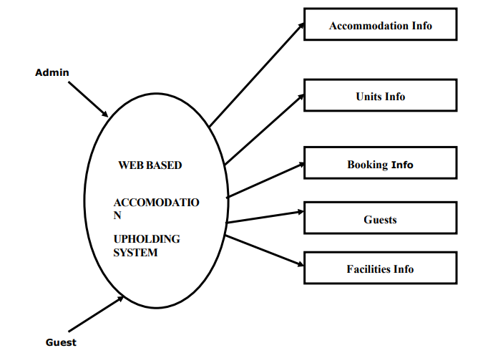

Figure no.1

**ER-Diagrams**

The entity Relationship Diagram (ERD) depicts the relationship between the data objects. The ERD is the notation that is used to conduct the date modeling activity the attributes of each data object noted is the ERD can be described resign a data object descriptions.

The set of primary components that are identified by the ERD are

* Data object
* Relationships
* Attributes
* Various types of indicators.

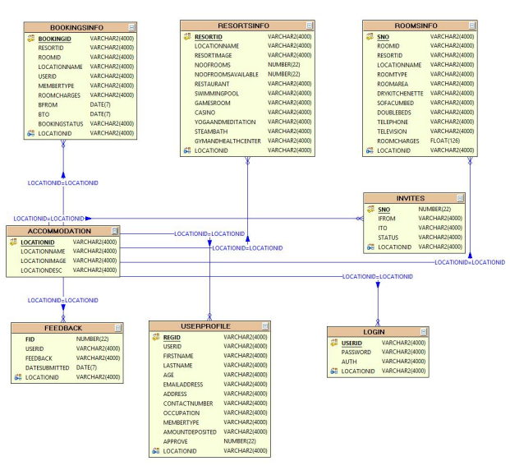The primary purpose othe ERD is to represent data objects and their relationships.

**Figure no.2**

**ADVANTAGES AND DISADVANTAGES**

Advantages:

Sometimes it happens that the rooms get booked soon when one visits the place therefore user can make advance booking using this system. It saves user time in search of rooms. The system is useful as it calculates an exact cost for requested number of days. It saves organization resources and expenses. This system is effective and saves time and cost of users. Easy registration.

Disadvantages:

The booking process usually requires a customer identity which the system cannot detect. It requires a reliable internet connection. Applications: This system can be applied in hotels. It can also be implemented in resorts.

**TEMPLATE**

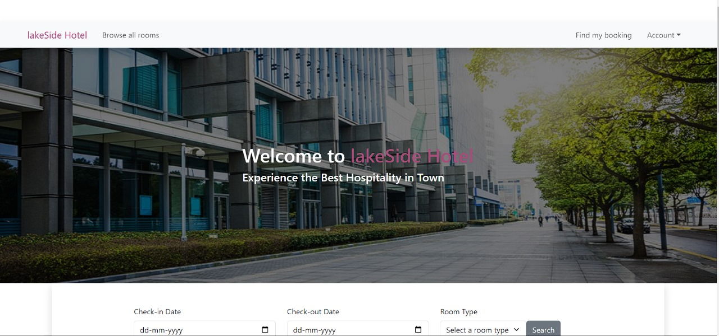

**Figure no.3**

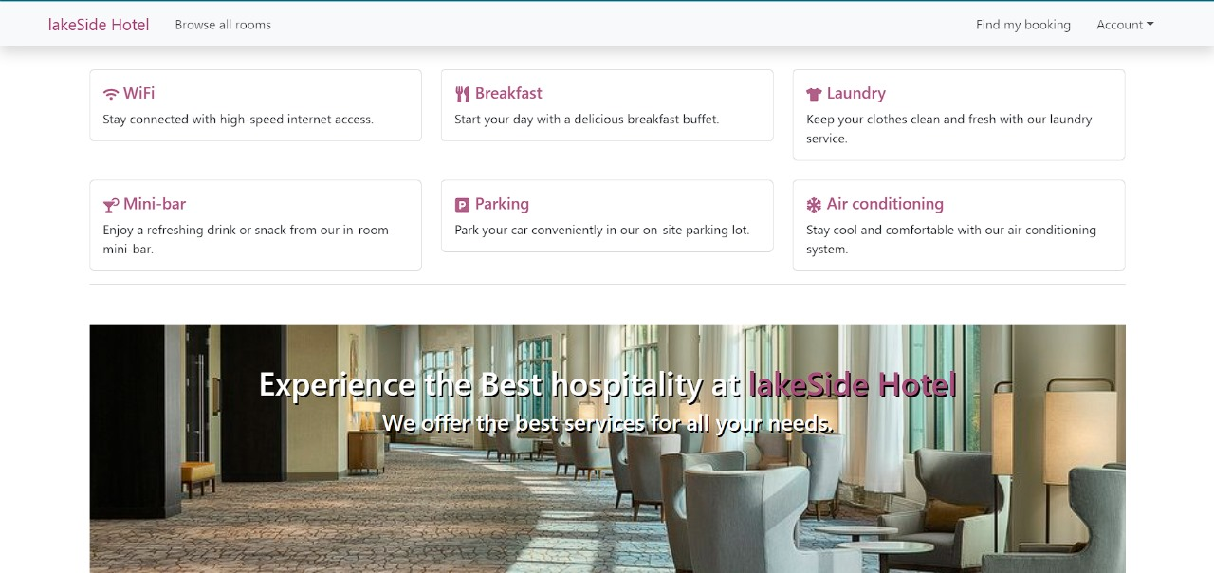

**Figure no.4**

**CONCLUSION**

**HOTEL MANAGEMENT SYSTEM** is a Web-portal Development Company specializing in providing custom solutions for small businesses. We strive to build solutions to your specific needs to get the job done right the first time. We pay special attention to the ease of use and utilize the latest in technology.

This system is developed for the exclusively for the people . It provides facilities to the user with user friendly modules with sub modules. This system is developed in understandable approach which can be easier to the layman of the computers.

This system is developed totally GUI based and with smart links. This project is designed to meet the requirements of Online Hotel Management. It has been developed in JSP, Servlets keeping in mind the specifications of the system. For designing the system we have used simple data flow diagrams.

Overall the project teaches us the essential skills like: Using system analysis and design techniques like data flow diagram in designing the system. Understanding the database handling and query processing.

**REFERENCES**

• <https://www.w3schools.com/html>

• <https://www.w3.org/style/css>

• <https://wikepedia.or/wiki/MySQL>

• <https://wikipedia.org/wiki/javascript>

• <https://httpd.apache.org>

• <https://w3schools.com/php>

• Learning PHP, MySQL & JavaScript: With j Query, CSS & HTML

• Java: The Complete Reference: Herbert Schildt